**Diagonalization Report**

# Schematic of the network:

|  |  |  |
| --- | --- | --- |
|  | Parameter | Value |
| Number of network lines | $$nl$$ | 3 |
| Number of network buses | $$nb$$ | 3 |
| Vector with network lines' "sending buses" | $$FromBus$$ | [1,1,2] |
| Vector with network lines' "receiving buses" | $$ToBus$$ | [2,3,3] |
| Number of Generators | $$ng$$ | 3 |
| Number of competing aggregators | $$ncda$$ | 2 |
| Vector with Generation Buses | $$GenBus$$ | [1,1,3] |
| CDABus | $$CDABus$$ | [2, 3] |
| Bus with strategic aggregator | $$DABus$$ | 1 |
| Vector with Capacities of Network Lines in pu | $$FMAX$$ | [50, 50, 50] |
| Susceptance matrix | $$Yline$$ | [100, -100, 0; 125, 0, -125; 0, 150, -150] |
| Generators Capacity | $$gen_capacity$$ | [5 , 10 , 6] |

Each demand aggregator (DA) has 2000 prosumers. Penetration of solar power and electric vehicles in each segment of the network are:

|  |  |  |
| --- | --- | --- |
| DAs | Electric Vehicle | Solar Power |
| DA1 | 75 % | 50 % |
| DA2 | 50 % | 30 % |
| DA3 | 30 % | 15 % |

Simulation horizon is for 24 hours forecast of prosumers loads. Supposed it is for time 16 to 40. DAs start non-cooperative game from time 12 and market close at 16 to process all the bids.

Results related to diagonalization iteration after 500 iterations solving models 1500 times.

**MPEC objective functions**

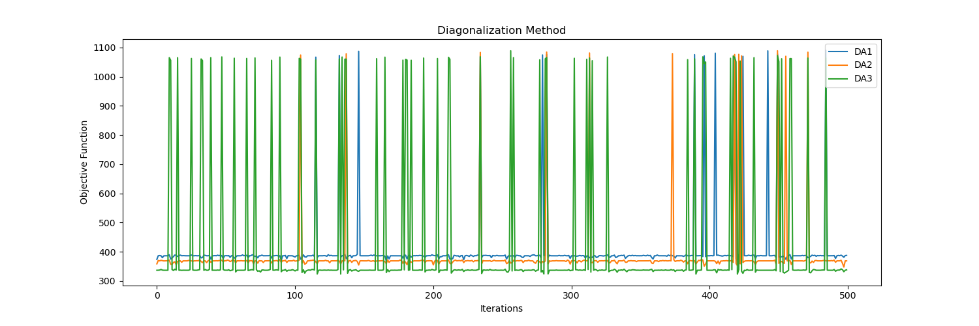

Figure 1:MPECs objective functions

There are some oscillations in the values of MILP model as we can see in the figure. If we look to their density distribution in below figure, we can see most of them are around two parts:

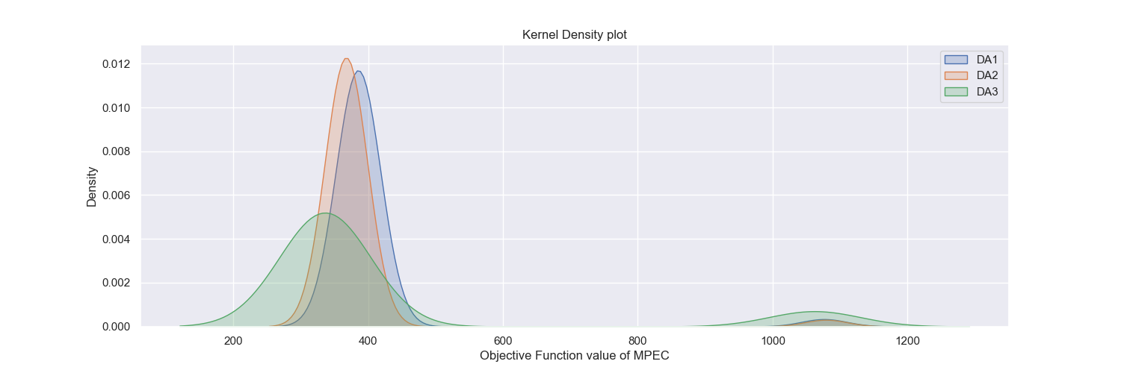

We can see this from scatter plot of DAs:

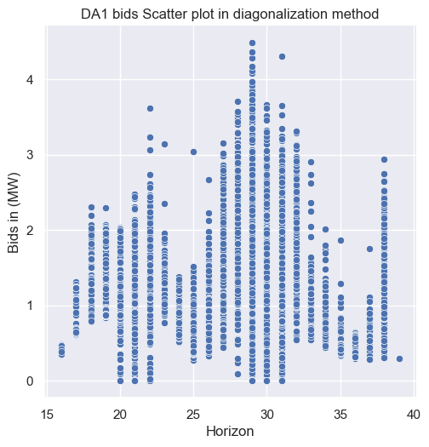 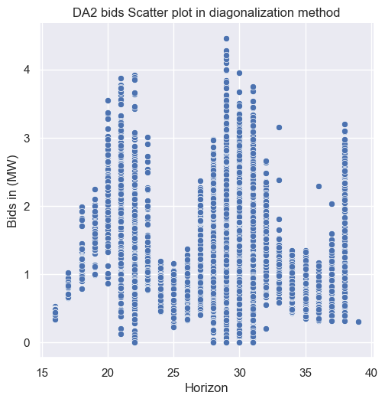 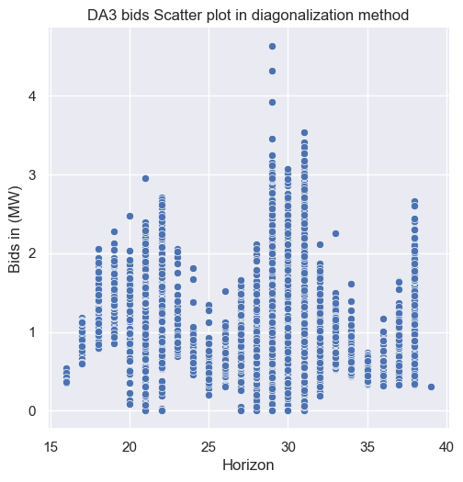

To compare the objective function value for each MPEC the plot of average loads values with 95 percent confidence interval presented below:

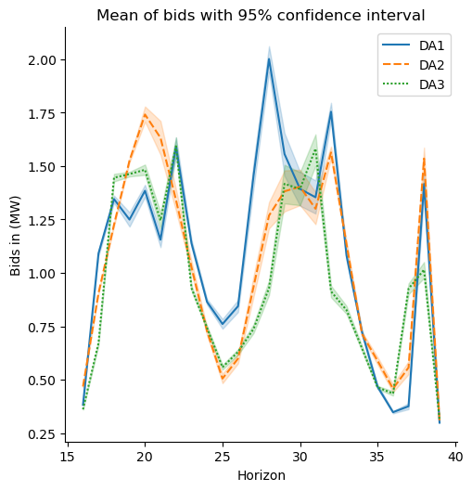

**Power cost based on LMPs**

Considering loads and offers from each DA and nodal price (LMP) the plot of the values are below:

$$\sum_{t ∈ H}{\left\{λ_{i,t}⋅(E_{t}^{DA, \overline{∧}}-E_{t}^{DA, \underline{∨}})\right\}}$$

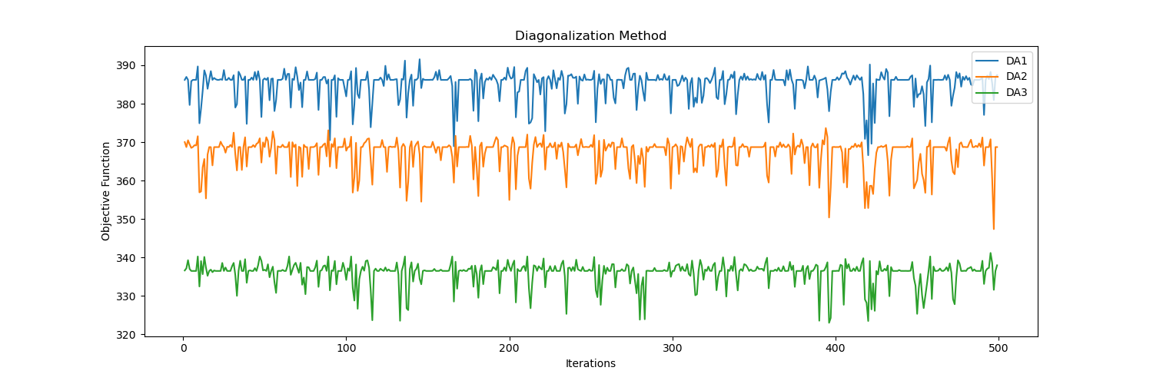

The average plot of the above cost function :

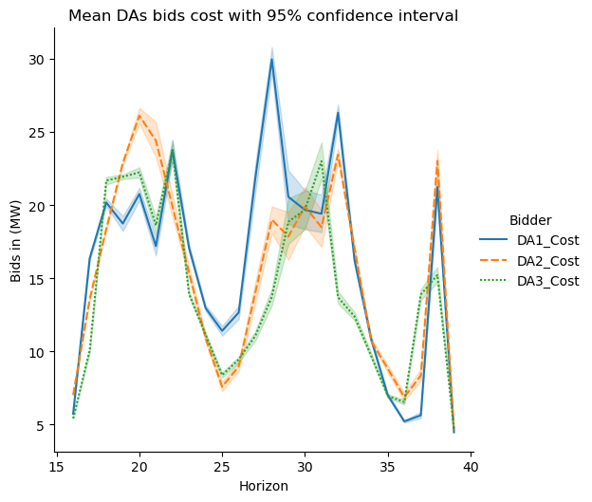

Plot of the values looks like the load’s plots in previous page.

**Demand and offer plot for each DA**

To choose on instance as selected iteration, one with smallest sum of three DAs cost function during iterations selected as best response from all DAs.

In this experience iteration 210 has the smallest sum of three DAs.

$$\min{\sum_{for all DAs}{\sum_{t ∈ H}{\left\{λ_{i,t}⋅(E_{t}^{DA, \overline{∧}}-E_{t}^{DA, \underline{∨}})\right\}}}}$$

**DA1 Loads and offer:**

Comparing average load $E_{t}^{DA, \underline{∨}}$ in all iterations with selected bid iteration 210.

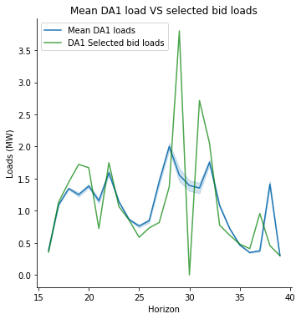

Comparing average offer $E_{t}^{DA, \underline{∨}}$ in all iteration with selected bid iteration 210.

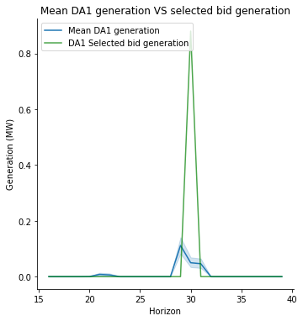

DA1 average power cost and iteration 210 which is looks similar with first figure but different values for cost here and load previous page.

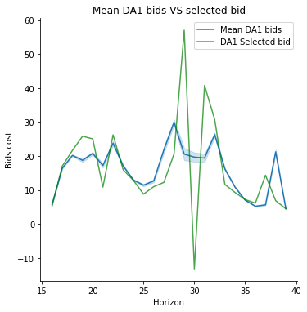

Average of all load types of DA1:

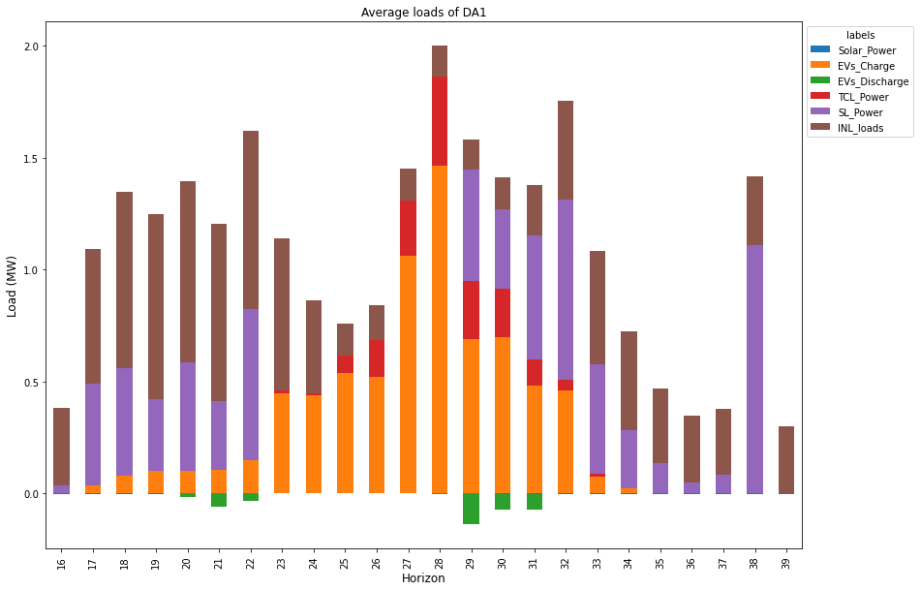

**DA2 loads and offer:**

Average of bids comparing with selected bid iteration 210

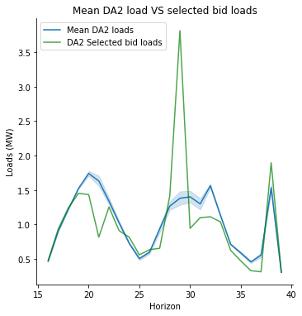

Average offer and selected bid:

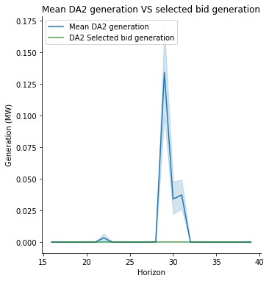

Average cost and selected bid:

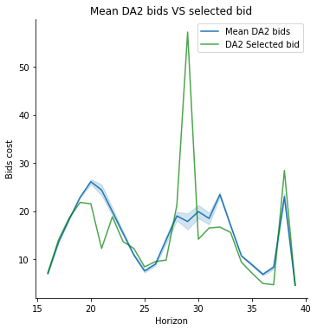

Average of all load types of DA2:

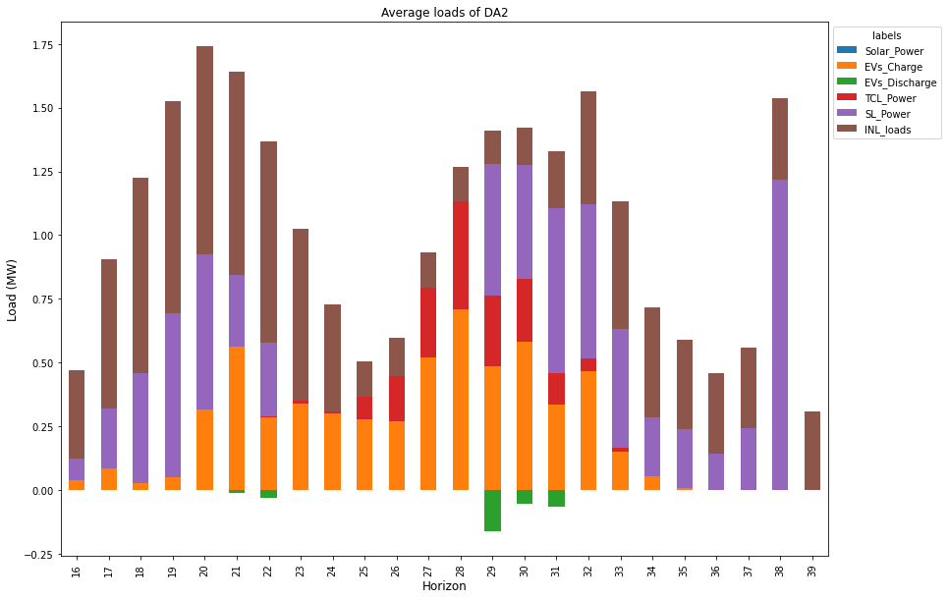

**DA3 loads and offer:**

Average of bids comparing with selected bid iteration 210

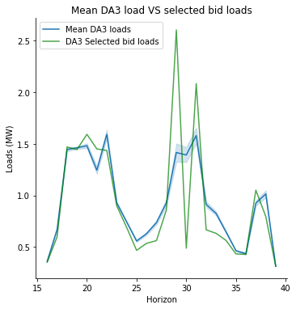

Average offer and selected bid

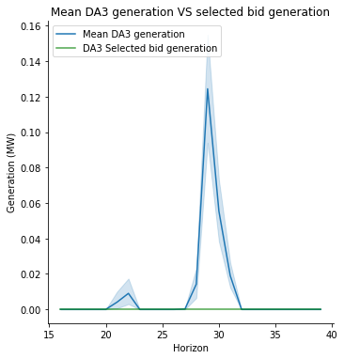

Average cost and selected bid:

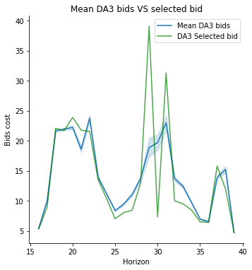

**Generators loads:**

There is mainly one generator dispatched to fulfill demands G1

